📚 Copying Course Content in D2L Brightspace
Duplicate course content from a previous semester into your new course shell with ease. This guide walks you through copying content as an instructor, ensuring your materials are ready for the new term.

🧠 Key Terms
Term | Meaning
Source Course | The course you're copying content from (e.g., “ENG-111-WN801-24/FA”).
Destination Course | The new course you're copying content into (e.g., “ENG-111-WN801-25/SP”).

🛠 How to Copy a Course

1. Access the Destination Course
Log in to D2L Brightspace.
In the “My Courses” section, click and open your new semester's course (Destination Course). Verify you are in an empty course.

2. Navigate to the Course Import Tool
Inside the Destination Course:
- Click Edit Course from the navbar.
- Under Site Resources, select Import/Export/Copy Components.

3. Select Copy Option
- Choose “Copy Components from Another Org Unit.”
- Click Search for offering to locate your Source Course.
- Type part of the course name/code (e.g., “ENG-111”) and click Search.
- Click the radio button next to your Source Course and press Add Selected.

4. Choose Copy Type
You now have two options:
- ✅ Copy All Components – Copies everything (recommended for full course duplication).
- 🛠 Select Components – Choose specific items like Content, Assignments, Quizzes, etc.
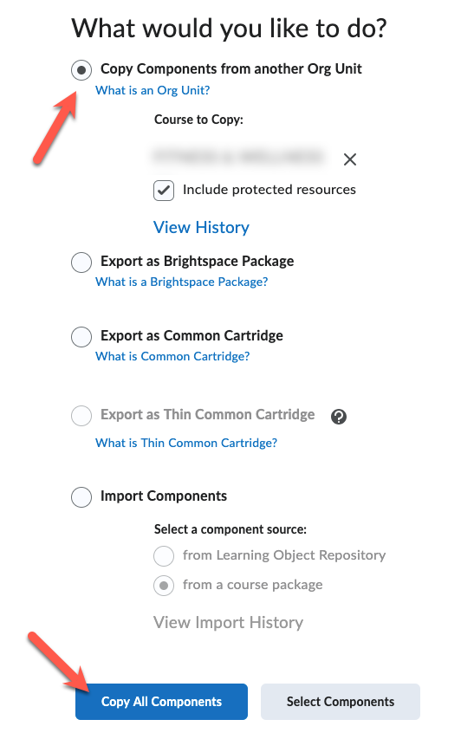
Click Continue.

5. Customize Selection (Optional)
If you selected "Choose Components":
- Check off the tools you want to copy (e.g., “Content”, “Assignments”, “Rubrics”).
- You can also choose “Include associated files” to ensure files like PDFs and images come with it.
Click Continue and then Finish.

6. Watch the Progress Bar
D2L will show you a progress bar. Once it finishes, you'll see a green checkmark and confirmation message:
✅ "Copy Completed Successfully."

7. Review and Update
Visit Content, Assignments, Quizzes, and Grades to:
- ✅ Verify everything copied correctly.
- 🗓 Update due dates and availability.
- ✏ Edit announcements or syllabus as needed.

💡 Tips & Best Practices
✅ Adjust Start/End Dates – Quizzes, modules, and dropboxes may have old dates.
✅ Check for Broken Links – Especially if you linked to older course-specific resources.
✅ Use "Manage Files" to clean up unused or outdated materials after copying.

